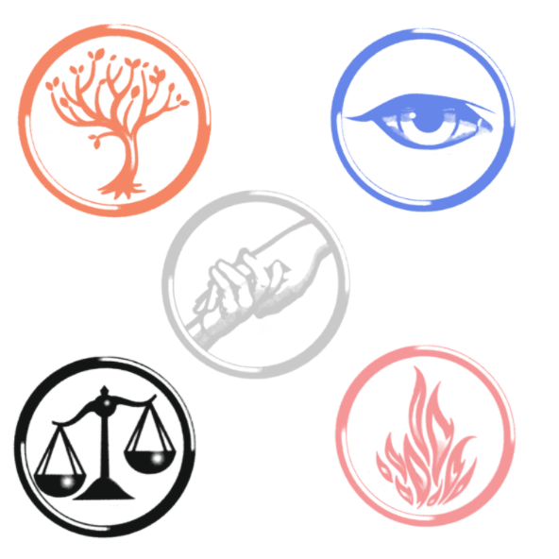
Academic vs Informal Writing

Name: _____________________________________

1. Circle the sentence you find easier to read and understand.

I don’t know because I haven’t gotten to that part of the book yet but I think that Roth is trying to say that people are complex and cannot fit into just one group because they are all different, even if that sounds like a cliché. | Roth shows that people are too complex to fit into one group.

Why did you choose that sentence?
________________________________________________________________________________
________________________________________________________________________________
________________________________________________________________________________
________________________________________________________________________________

2. Uncertainty has its place
I don’t know but maybe it’s about how we shouldn’t let the government sort people into factions, but also maybe it’s about how people should make those choices for themselves. | Perhaps Roth’s intention is to argue against systems that limit people’s freedom, but an alternative interpretation would be that it is the individual’s responsibility to know and accept their identity.

Underline the words that show uncertainty. Which version sounds more suitable for an essay? Why?
________________________________________________________________________________
________________________________________________________________________________
________________________________________________________________________________
________________________________________________________________________________

3. Turn informal writing into academic writing
Look at how the meaning stays similar while the writing becomes clearer and more direct.
Instead of... | Write:
I believe Tris is brave because she makes difficult choices. | Tris shows courage when she makes difficult choices.
I think the faction system is unfair. | The faction system is unfair because it limits people’s choices.
In my opinion, Tris does not really fit into one faction. | Tris does not fit neatly into one faction, showing that the system is too strict.

Rewrite this sentence so it is clearer and more suitable for an essay:
“This kind of shows that Tris is different from everyone else.”
________________________________________________________________________________
________________________________________________________________________________
________________________________________________________________________________
________________________________________________________________________________
Now rewrite this one:
“I personally think that maybe Roth is trying to show that the faction system isn’t very good.”
________________________________________________________________________________
________________________________________________________________________________
________________________________________________________________________________
________________________________________________________________________________

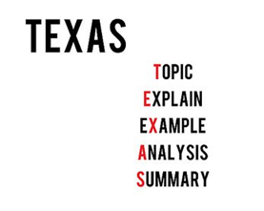
4. Write a TEXAS paragraph

Question: How does Roth use Tris to explore the idea of individual identity in Divergent?
________________________________________________________________________________
________________________________________________________________________________
________________________________________________________________________________
________________________________________________________________________________
________________________________________________________________________________
________________________________________________________________________________
________________________________________________________________________________
________________________________________________________________________________
________________________________________________________________________________
________________________________________________________________________________
________________________________________________________________________________
________________________________________________________________________________
________________________________________________________________________________
________________________________________________________________________________
________________________________________________________________________________
________________________________________________________________________________
________________________________________________________________________________

5. Exchange papers and read as a peer
Peer reviewer: ____________________________

If you see words or phrases that do not need to be there, underline them. Look for filler, repeated ideas, conversational phrases, or extra words that do not add extra meaning.

If you can’t find any, explain why:
________________________________________________________________________________
________________________________________________________________________________
6. Give respectful, useful feedback
One part of your paragraph that was clear was ____________________________________________
because ____________________________________________________________________________.
As a reader, I was unsure about _______________________________________________ because
____________________________________________________________________________.
I think the words or phrase ____________________________________________________ could be
removed because ______________________________________________________________________.
One change I would suggest is __________________________________________________________
because ____________________________________________________________________________.

8. Use the feedback
Read your peers’ feedback and choose what’s useful to you.

Rewrite one sentence from your paragraph.

Before:
________________________________________________________________________________
________________________________________________________________________________
After:
________________________________________________________________________________
________________________________________________________________________________

9. Reflection
What did you notice while reading your peer’s paragraph that you do not normally notice when writing?
________________________________________________________________________________
________________________________________________________________________________
________________________________________________________________________________
________________________________________________________________________________
What is one thing you will do differently in your in-class essay?
________________________________________________________________________________
________________________________________________________________________________
________________________________________________________________________________
________________________________________________________________________________

