ANIMATED FILM DETECTIVE
Name: __________________________________________
Identify the shot and/or camera angle, then explain the effect of that choice. Think about what that film device communicates to the audience. Bonus brownie points if you can identify the movie.
FILM STILL | SHOT / ANGLE | EFFECT / MEANING
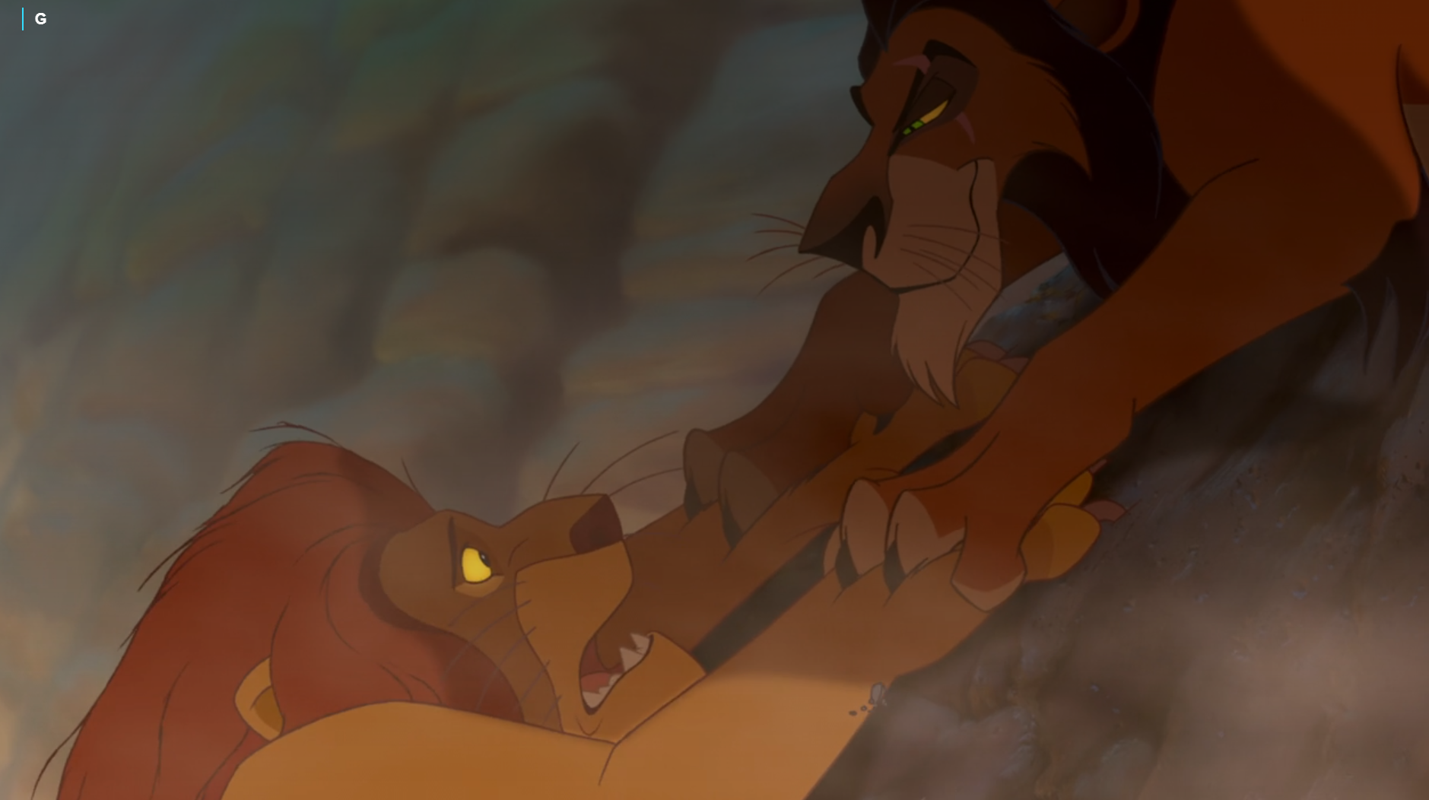 | 1.  ________________________________  ________________________________ | ____________________________________________________  ____________________________________________________  ____________________________________________________  ____________________________________________________  ____________________________________________________  ____________________________________________________
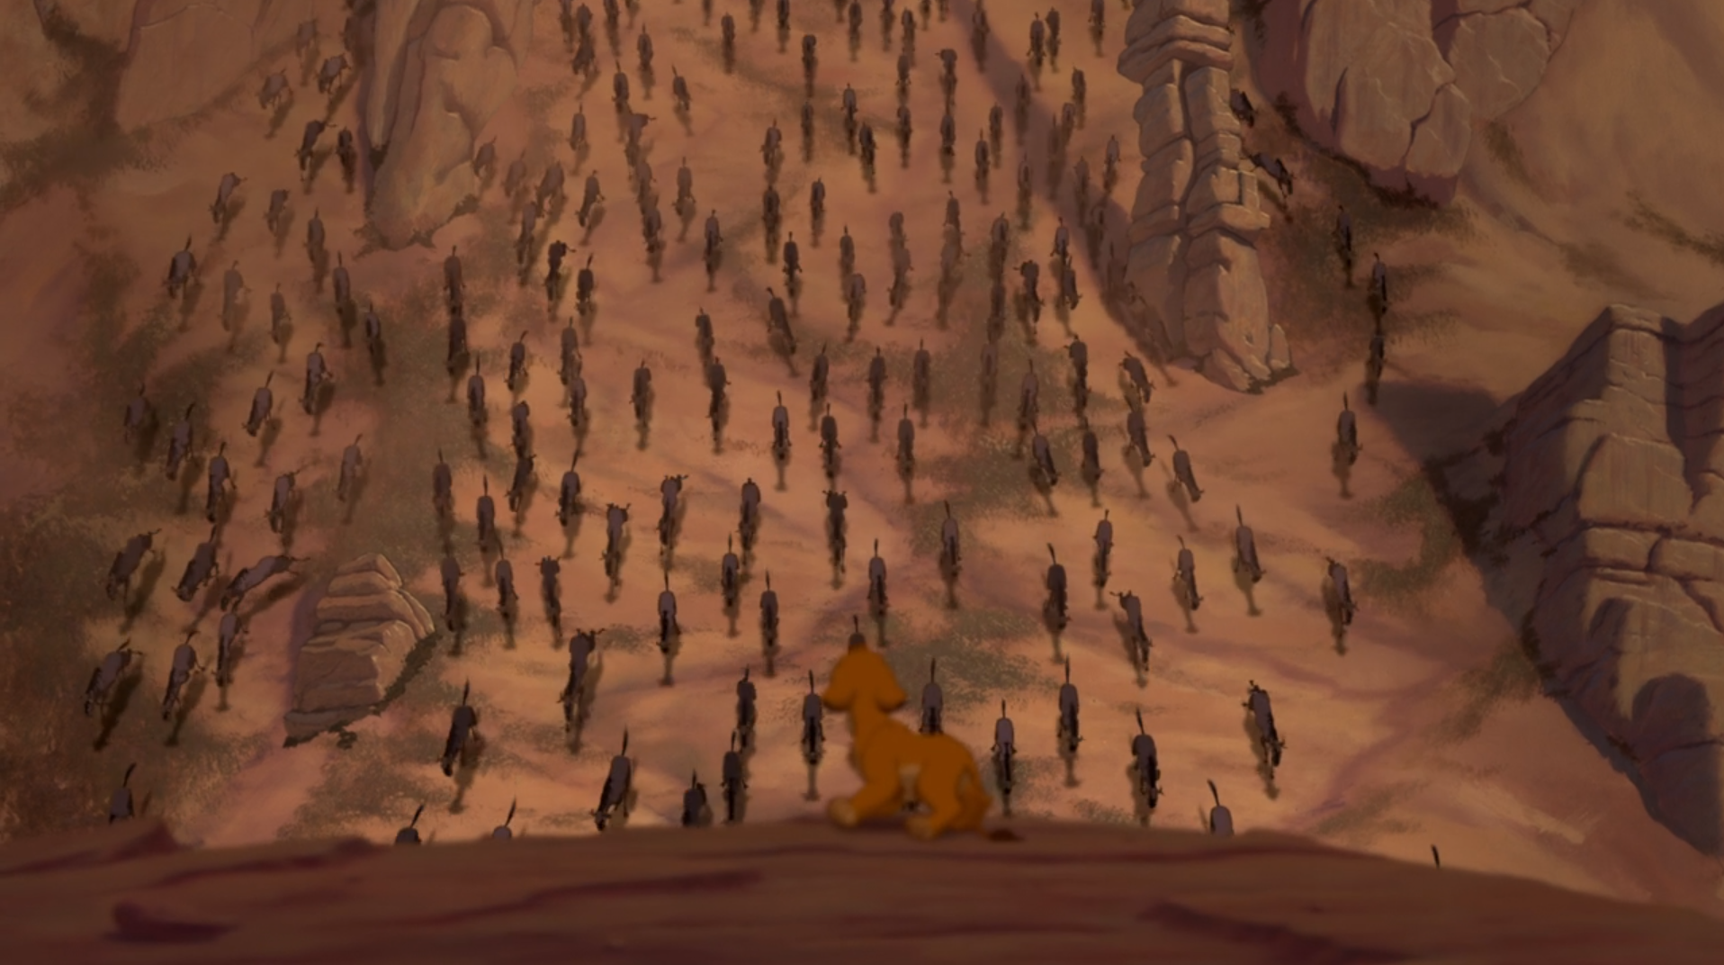 | 2.  ________________________________  ________________________________ | ____________________________________________________  ____________________________________________________  ____________________________________________________  ____________________________________________________  ____________________________________________________
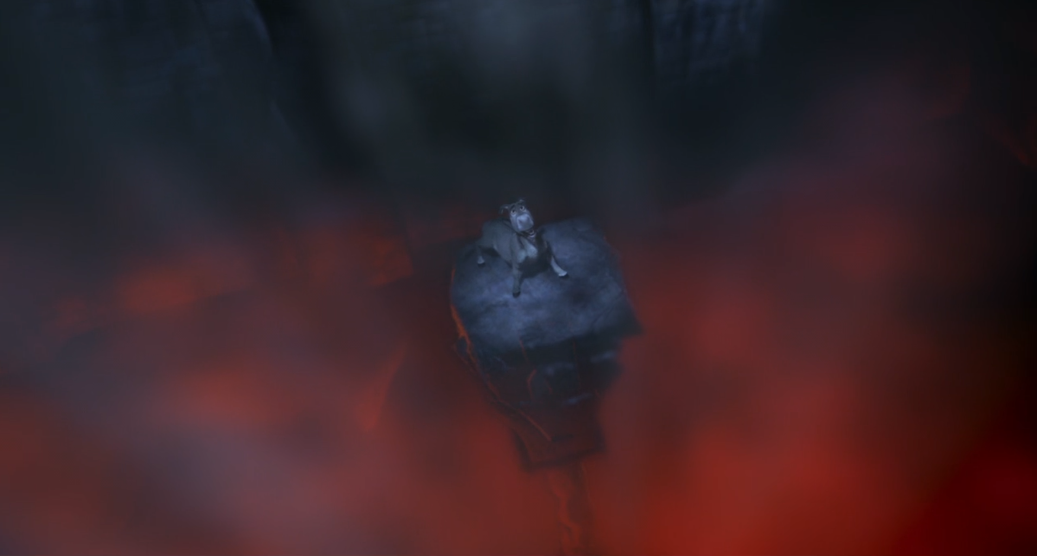 | 3.  ________________________________  ________________________________ | ____________________________________________________  ____________________________________________________  ____________________________________________________  ____________________________________________________  ____________________________________________________
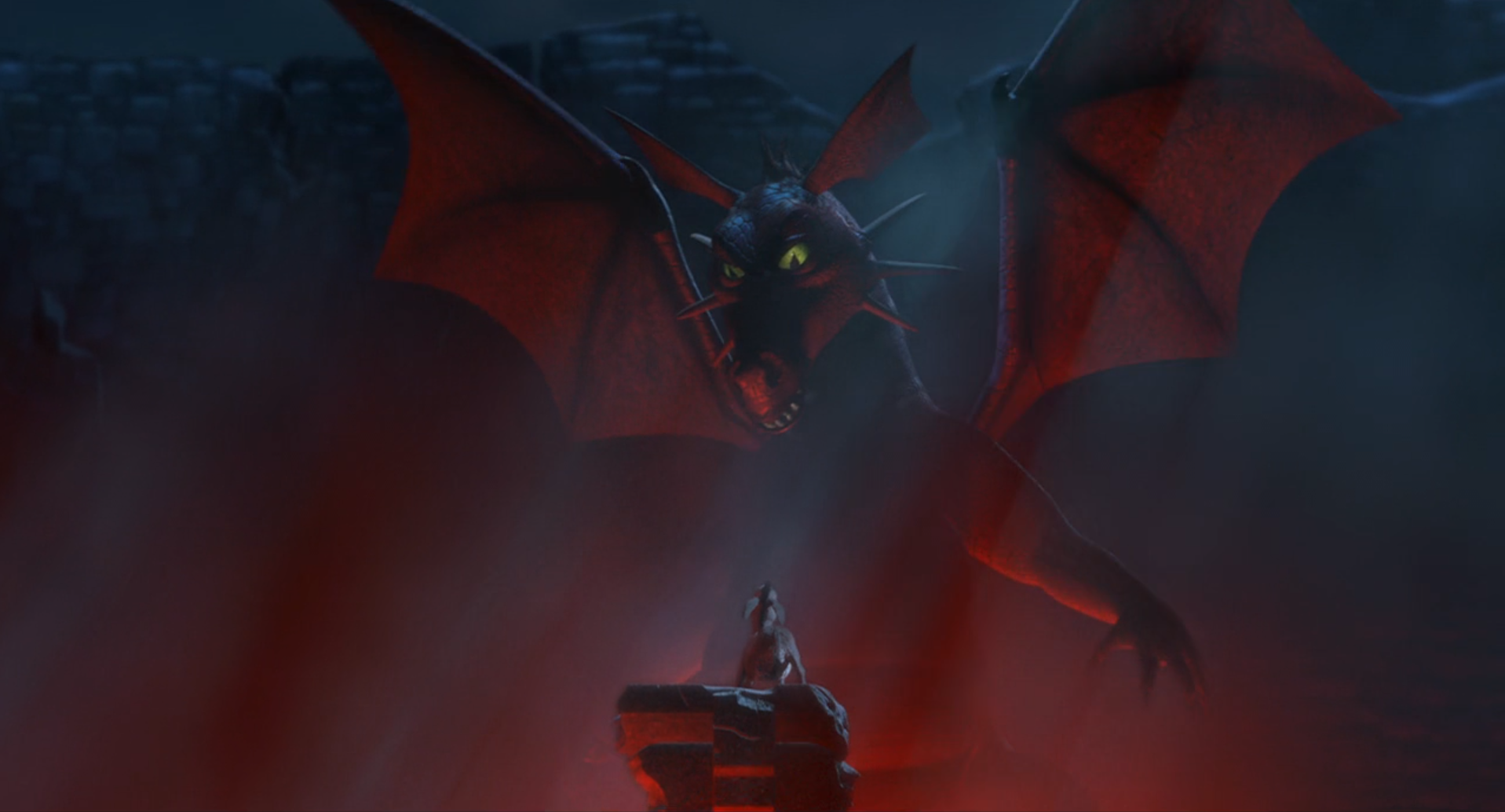 | 4.  ________________________________  ________________________________ | ____________________________________________________  ____________________________________________________  ____________________________________________________  ____________________________________________________  ____________________________________________________
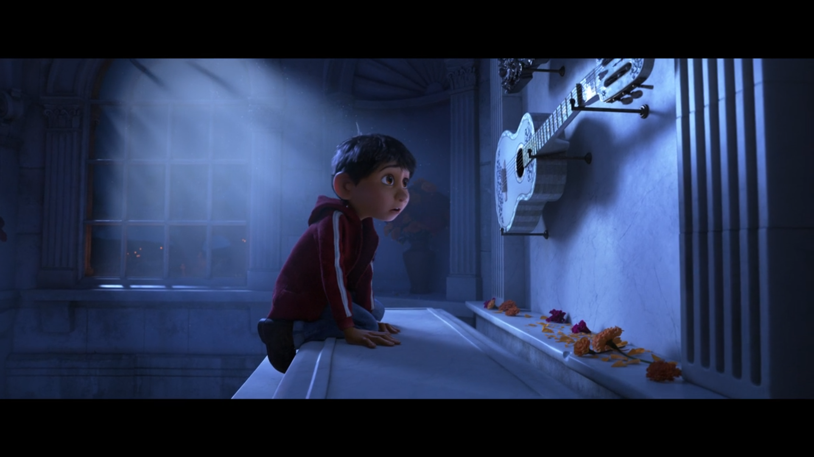 | 5.  ________________________________  ________________________________ | ____________________________________________________  ____________________________________________________  ____________________________________________________  ____________________________________________________  ____________________________________________________
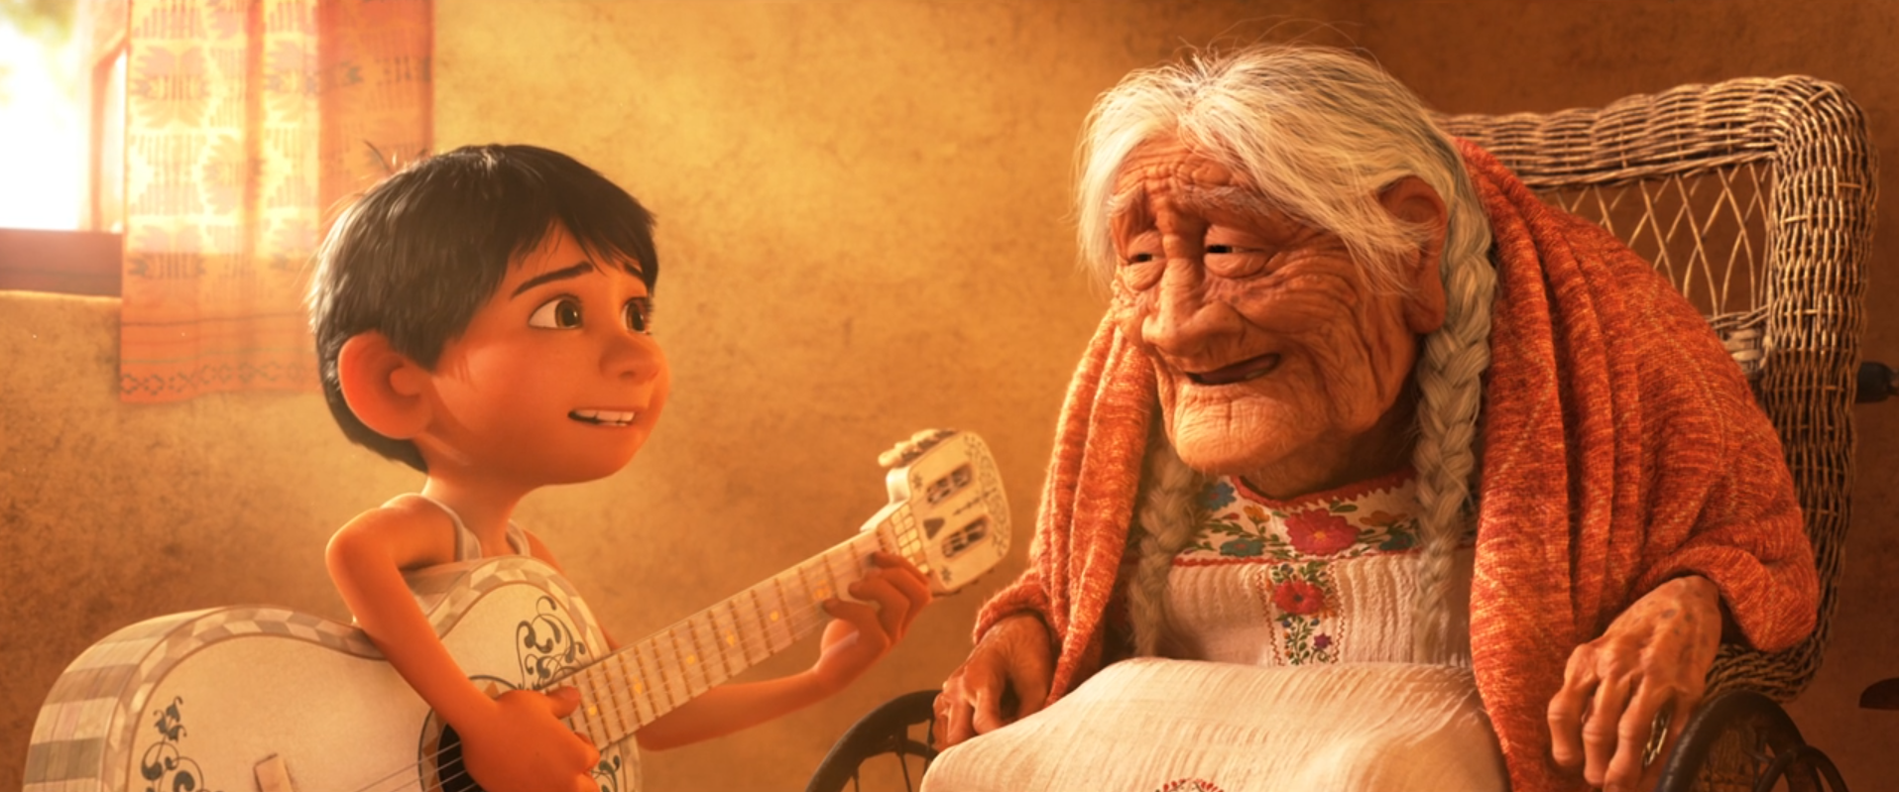 | 6.  ________________________________  ________________________________ | ____________________________________________________  ____________________________________________________  ____________________________________________________  ____________________________________________________  ____________________________________________________
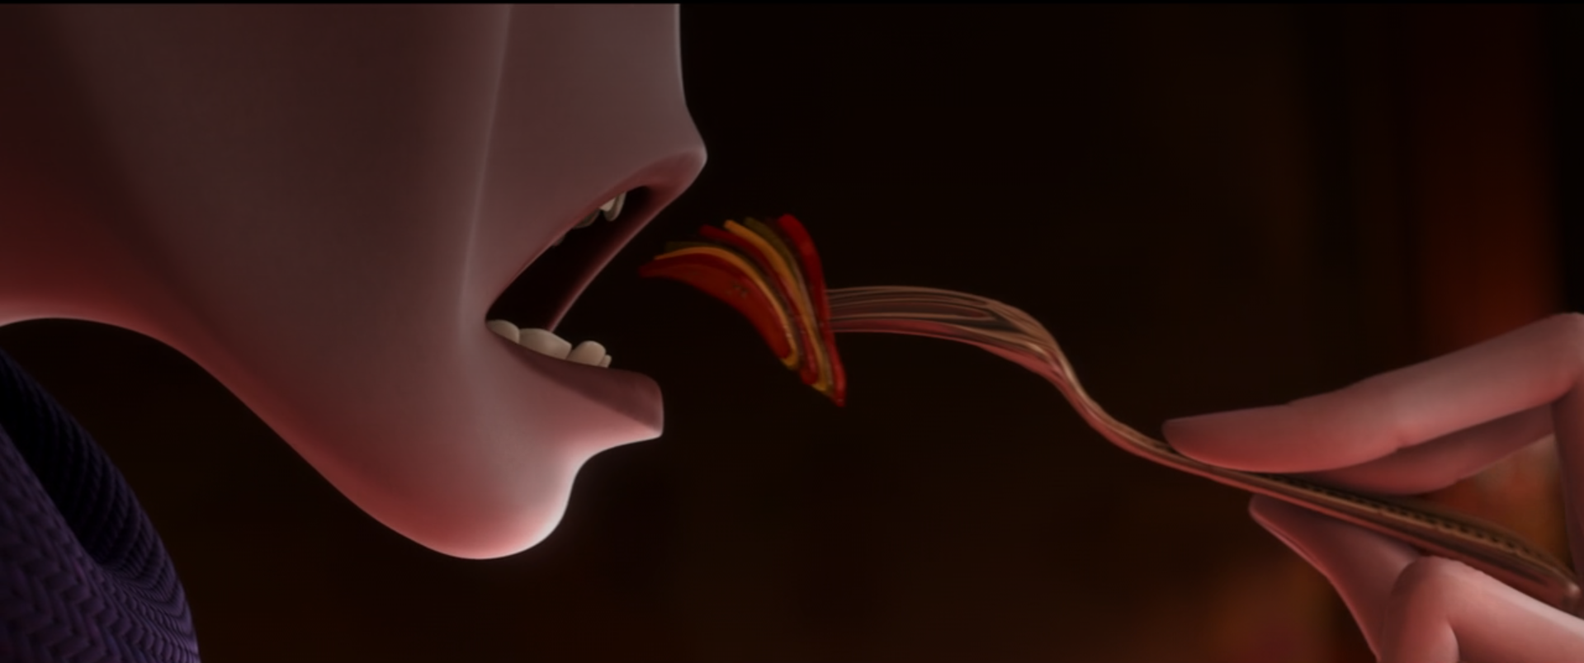 | 7.  ________________________________  ________________________________ | ____________________________________________________  ____________________________________________________  ____________________________________________________  ____________________________________________________  ____________________________________________________
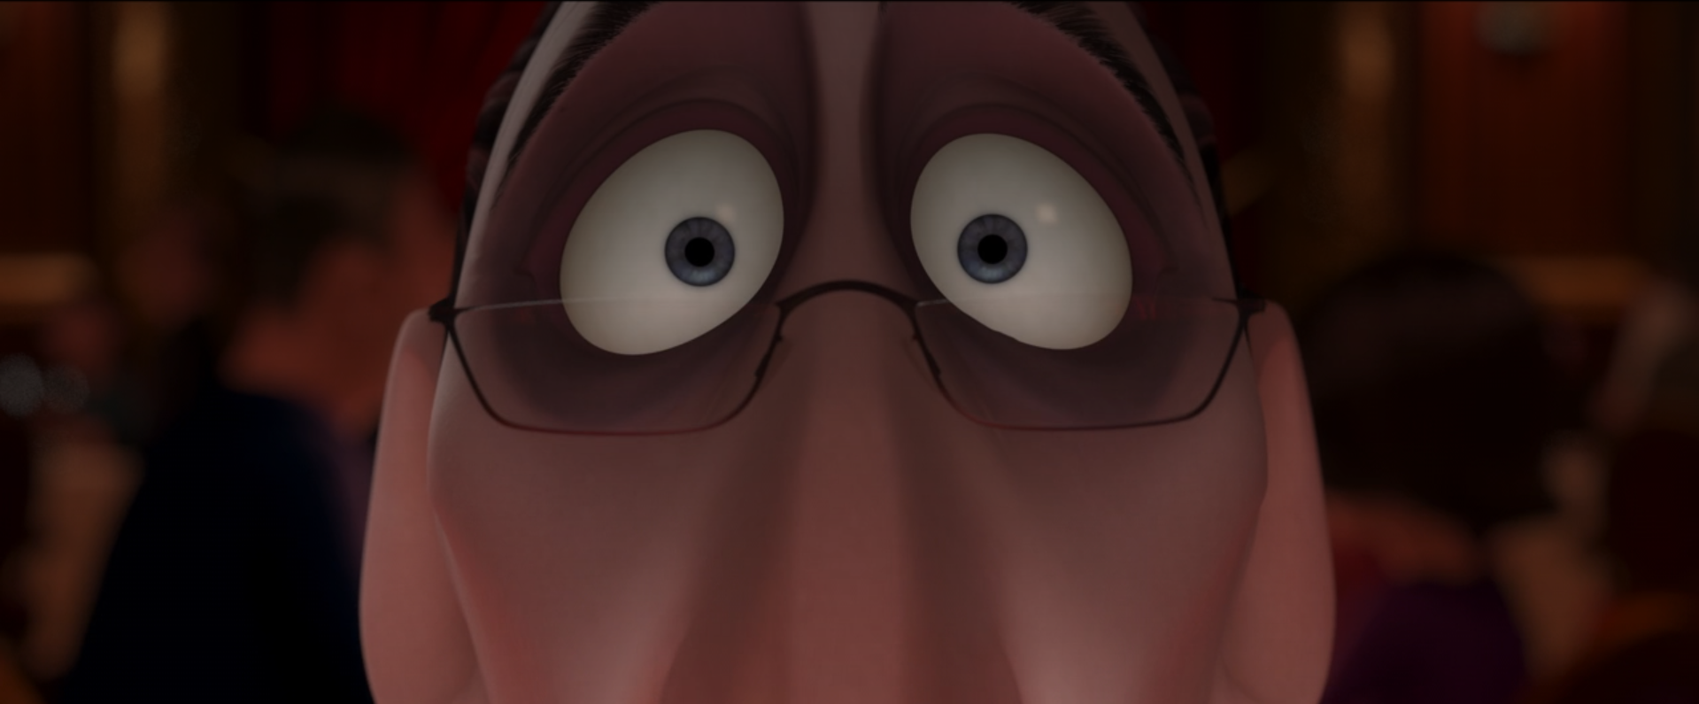 | 8.  ________________________________  ________________________________ | ____________________________________________________  ____________________________________________________  ____________________________________________________  ____________________________________________________  ____________________________________________________
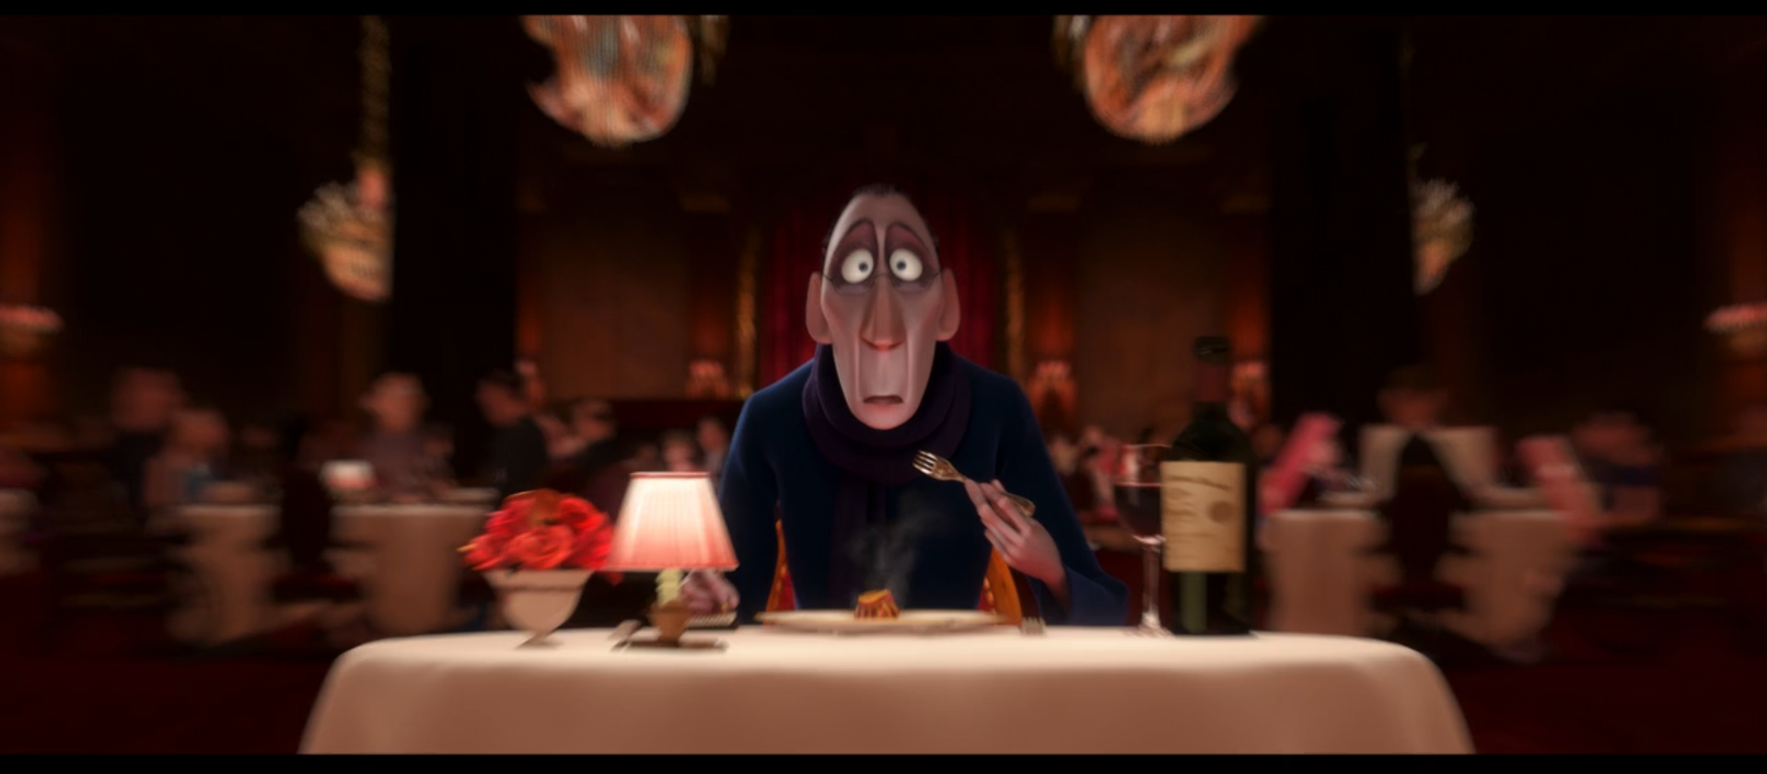 | 9.  ________________________________  ________________________________ | ____________________________________________________  ____________________________________________________  ____________________________________________________  ____________________________________________________  ____________________________________________________

WALL-E: SHOT SIZE GUIDE
FILM STILL | SHOT SIZE | EFFECT / MEANING
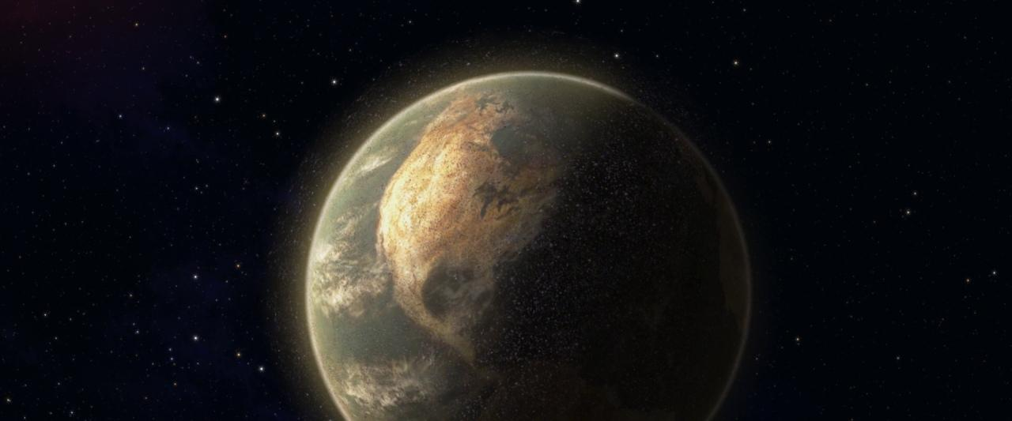 | EXTREME LONG / EXTREME WIDE SHOT  The setting dominates the frame. A character may be tiny or not visible at all. | Creates a strong sense of scale and shows the larger world of the story.
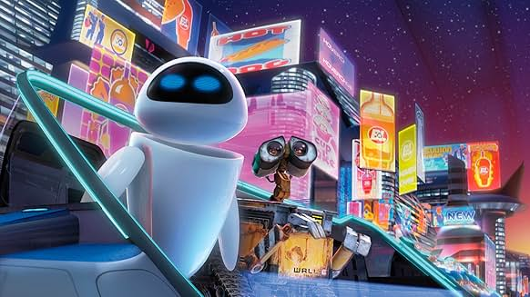 | LONG / WIDE SHOT  Shows the characters with plenty of the surrounding environment. | Lets us see both who is in the scene and where they are. The setting is still important.
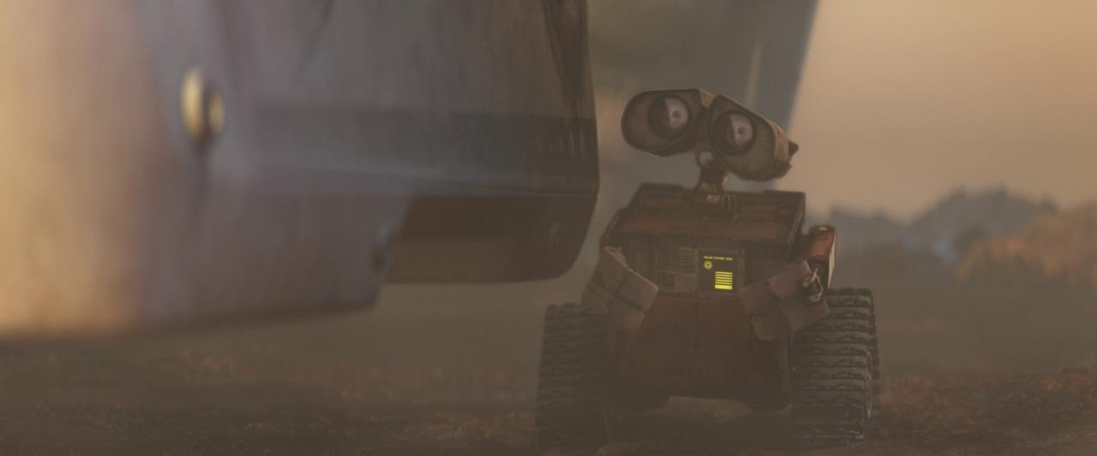 | FULL SHOT  Shows the character’s whole body in the frame. | Focuses attention on the character while still showing movement and some of the setting.
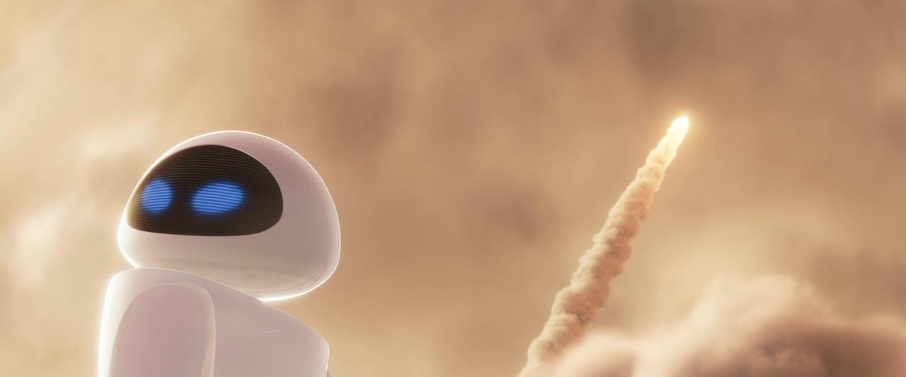 | MEDIUM-LONG SHOT  Shows most of the character, usually from around the knees upwards. | Brings us closer while keeping body language and some surroundings visible.
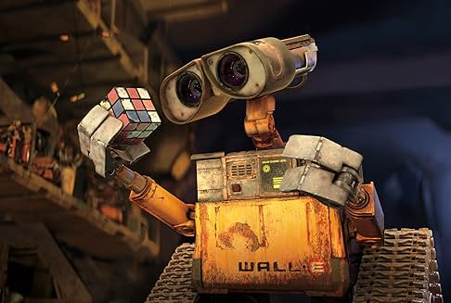 | MEDIUM SHOT  Shows roughly half of the character, often from around the waist upwards. | Draws attention to actions and body language while still showing some context.
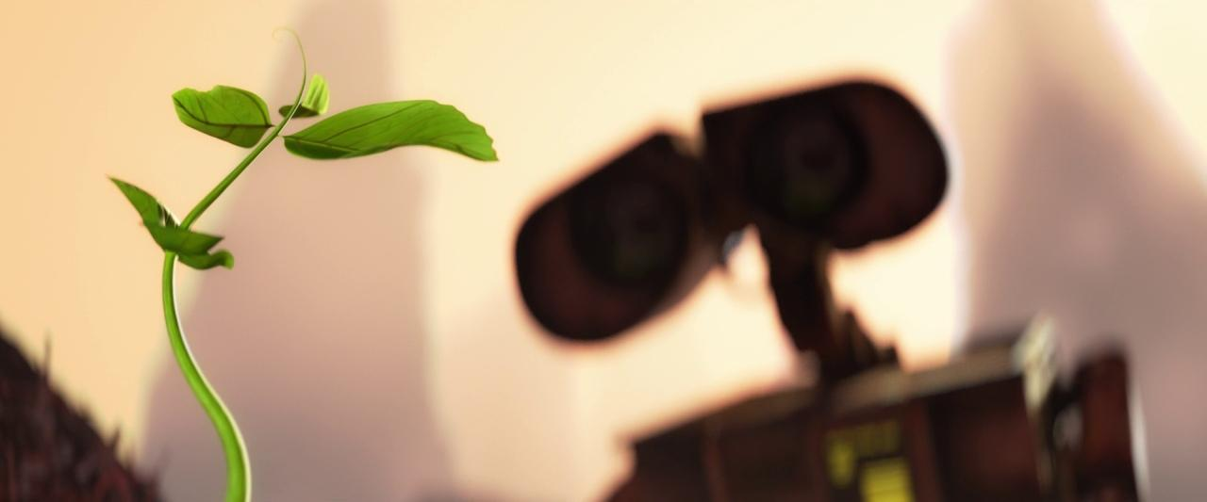 | MEDIUM CLOSE-UP  Shows WALL-E from roughly the chest or shoulders upwards. | Brings us closer to WALL-E, while the shallow depth of field makes the plant the main focus and signals its importance.
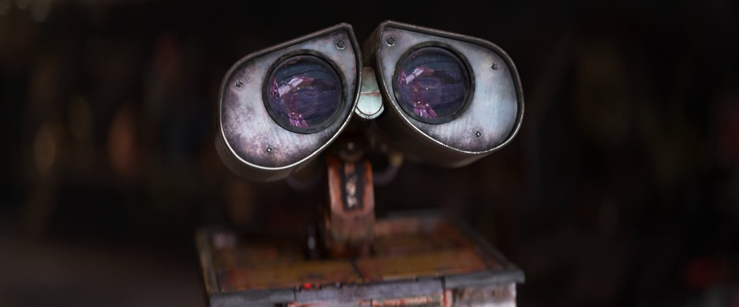 | CLOSE-UP  A face, character feature or important object fills most of the frame. | Directs our attention to emotion, reaction or an important detail.
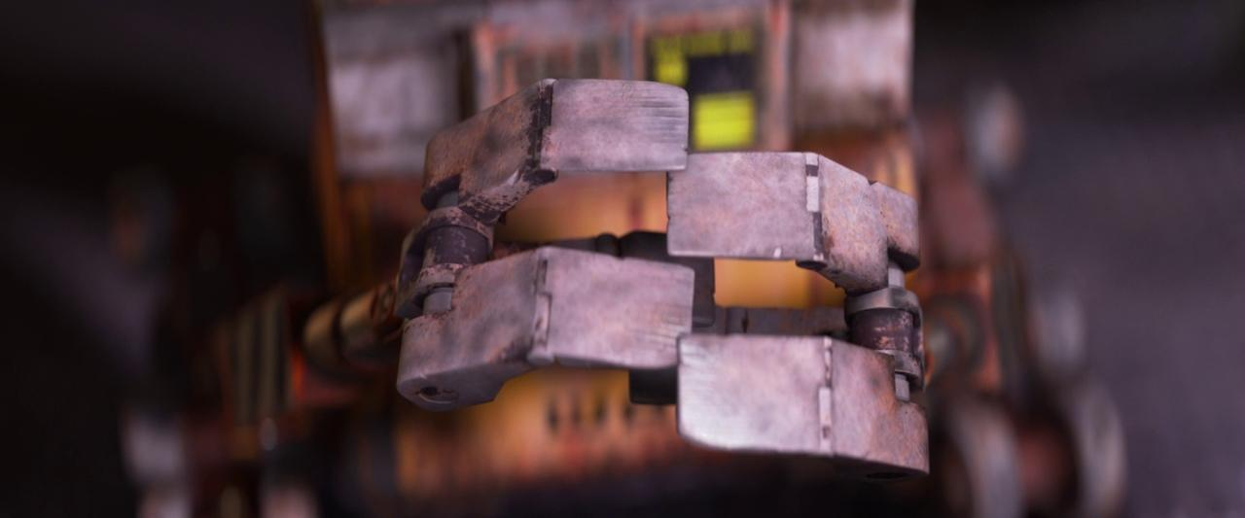 | EXTREME CLOSE-UP  One small detail fills the frame. Here, WALL-E’s hands dominate the image. | Creates strong emphasis and makes the audience focus on one specific detail.

